Transport Management project

**2020**

Covid-19

Group project part 1

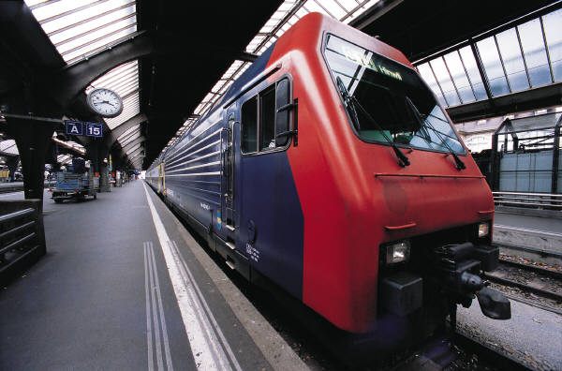

# C:\Users\Gee\Pictures\group.PNG

**2.1 FULL USE CASE DESCRIPTION**3

|  |  |  |
| --- | --- | --- |
| **Use case name:** | Place order | |
| **Scenario:** | Retailers place orders for agricultural products with emerging farmers | |
| **Triggering event:** | Transportation of goods placed by Retailers | |
| **Brief description:** | Fresh4u company has to receive orders from wholesalers/retailers to place, collect and deliver them to the Retailers | |
| **Actors:** | Retailers, farmer | |
| **Related use cases:** | Confirm order  Create payment  Track order | |
| **Stakeholders:** | Retailer, Farmer, transport(driver), admin | |
| **Preconditions:** | Retailer/wholesalers must exist | |
| **Postconditions:** | An order must be placed | |
| **Flow of activities** | **Actor** | **System** |
| 1.Place order  3. confirm order    5. make payment  7. track order  9. check truck availability  11.make route allocation  13 deliver package  14.Pay outstanding fees | 2.system display order  4. system display confirmed order  4.1 Calculate order cost  6. system create payment  8. system display order location  10. system display available trucks  12. system assign allocated routes to drivers  13.1System checks delivery time  13.2Calculate outstanding fees  13.3Update driver trips  15 system records total costs  15.1 system calculate driver payment |
| **Exception conditions:** | 1.4.1 invalid order | |

**2.2 STORYBOARDS**3

**2.3 ACTIVITY DIAGRAM**3

**2.4 SEQUENCE DIAGRAM**3

**2.5 STATE MACHINE DIAGRAM3**

